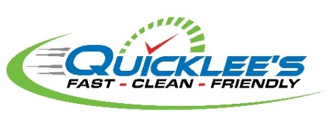
At Quicklee’s we offer our customers the option to either return items for a full refund within seven (7) days of purchase or to exchange items within thirty (30) days of purchase. An original receipt is required for all returns and exchanges.
Refunds for returns will be credited back to the original method of payment as indicated on the original purchase receipt. No refunds will be issued in cash unless the original form of payment as reflected in the original purchase receipt was cash. If the original form of payment is not available, store credit may be issued.
Quicklee’s reserves the right to decline any returns and/or exchanges where fraud is suspected or that do not meet the following requirements:
- Original receipts are required for all returns and/or exchanges – no copies or duplicates are accepted
- Purchases are eligible for refund only if the item is returned to a store within seven (7) days of the original purchase date
- Purchases are eligible for exchange only if the item is returned to a store within thirty (30) days of the original purchase date
- Purchases must be unused, in original packaging, and contain all original accessories to be eligible for return and/or exchange
- Purchases may only be returned and/or exchanged in-store
The following items are not eligible for return and/or exchange:
- Alcohol
- Lottery
- Gift Cards
- Holiday and Seasonal Items (if returned and/or exchanged after the applicable holiday)
If a guest does not have the original receipt, the return and/or exchange cannot be accepted.
Store management must approve any exceptions to this policy.
If you have any questions about Quicklee’s Company Return Policy, please contact us at https://www.quicklees.com/contact.

